PIZZA SALES PROJECT

This project analyzes the sales performance of a fictional pizza restaurant chain using MySQL for data querying and analysis and Power BI for interactive dashboard visualization. The analysis uncovers key insights related to revenue trends, order patterns, customer preferences, and product performance.

The dataset consists of four relational tables:
- orders – captures order-level information such as order ID, date, and time
- order_details – stores item-level details including quantity and pizza IDs
- pizzas – contains pricing and size information for each pizza
- pizza_types – provides pizza names, categories, and ingredient details

MYSQL QUERIES & RESULT

CONVERT DATE (order_date) COLUMN TO PROPER DATE FORMAT
update orders
set order_date=str_to_date(order_date,'%d-%m-%Y')

ALTER DATE (order_date) COLUMN TO DATE DATA TYPE
ALTER TABLE Orders
MODIFY COLUMN order_date DATE;

CONVERT DATE (order_time) COLUMN TO PROPER TIME FORMAT
update orders
set order_time =str_to_date(order_time,'%H:%i:%s');

ALTER TIME (order_Time) COLUMN TO TIME DATA TYPE
ALTER TABLE Orders
MODIFY COLUMN order_time TIME

DATA TYPES OF COLUMNS
describe orders;
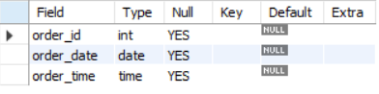

Total order

select count(distinct order_id) as TotalOrders from orders;

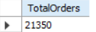

Total revenue
select round(sum(p.price*od.quantity),0) as Revenue from pizzas p
join order_details od on p.pizza_id=od.pizza_id;

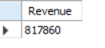

Total qty
select sum(quantity) as TotalQty from order_details;

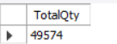

Identify the highest-priced pizza.
select pizzas.price,pt.name from pizzas
join pizza_types pt on pizzas.pizza_type_id=pt.pizza_type_id
order by pizzas.price desc
limit 1;

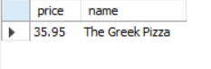

Identify the most common pizza size ordered.
select p.size ,count( distinct o.order_id) as cnt from pizzas p
join order_details o on p.pizza_id=o.pizza_id
group by p.size
order by cnt desc;

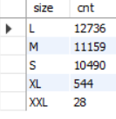

List the top 5 most ordered pizza types along with their quantities

SELECT
pt.name, SUM(od.quantity) AS totalqty
FROM
pizza_types pt
JOIN
pizzas p ON pt.pizza_type_id = p.pizza_type_id
JOIN
order_details od ON p.pizza_id = od.pizza_id
GROUP BY pt.name
ORDER BY totalqty DESC
LIMIT 5;

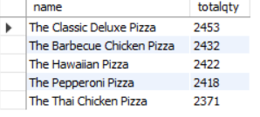

what is the total revenue by month?
SELECT
monthname(order_date) as month,
round(sum(p.price * od.quantity),0) AS Total

FROM
pizzas p
JOIN
order_details od ON p.pizza_id = od.pizza_id
JOIN
orders o ON od.order_id=o.order_id
group by monthname(order_date)
order by Total desc;

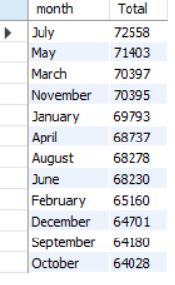

find the category-wise distribution of pizzas.
SELECT
category, COUNT(1) AS cnt
FROM
pizza_types
GROUP BY category
ORDER BY cnt DESC;

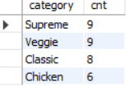

Total sales on weekday and weekend

SELECT
CASE
WHEN DAYOFWEEK(o.order_date) IN (1 , 7) THEN 'weekend'
ELSE 'weekday'
END AS day_of_week,
SUM(p.price * od.quantity) AS revenue
FROM
pizzas p
JOIN
order_details od ON p.pizza_id = od.pizza_id
JOIN
orders o ON od.order_id = o.order_id
GROUP BY day_of_week;

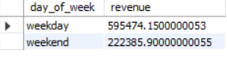

Determine the distribution of orders by hour of the day.
select hour(order_time) ,count(1)as no_of_orders from orders
group by hour(order_time);

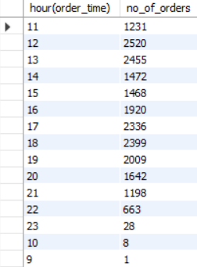

calculate the average number of pizzas ordered per day.
with order_qty as (
select o.order_date,sum(od.quantity) as total_order_qty from order_details od
join orders o on od.order_id=o.order_id
group by o.order_date),
avg_qty as (
select round(avg(total_order_qty),0) Avg_qty
from order_qty)
select * from avg_qty;

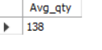

top 3 most ordered pizza types based on revenue.
with top_pizza as (
SELECT
pt.name, ROUND(SUM(p.price * od.quantity), 0) AS revenue
FROM
pizzas p
JOIN
pizza_types pt ON p.pizza_type_id = pt.pizza_type_id
JOIN
order_details od ON p.pizza_id = od.pizza_id
GROUP BY pt.name),
rank_pizzatype as (
select *,
rank() over(order by revenue desc) as rnk_revenue
from top_pizza)
select * from rank_pizzatype
where rnk_revenue<=3;

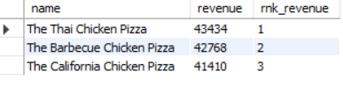

which pizza sold the most in totals revenue and qty?
SELECT
pt.name,
round(SUM(p.price * od.quantity),0) AS TotalRevenue,
sum(od.quantity) as totalqty
FROM
pizzas p
JOIN
order_details od ON p.pizza_id = od.pizza_id
JOIN
pizza_types pt ON p.pizza_type_id = pt.pizza_type_id
GROUP BY pt.name
ORDER BY TotalRevenue DESC
LIMIT 1;



Calculate the percentage contribution of each pizza type to total revenue.
select pt.category,
round (
sum(p.price*od.quantity)*100/
( select sum(p2.price*od2.quantity) from pizzas p2
join order_details od2 on p2.pizza_id=od2.pizza_id),2)as revenue_per
FROM
pizzas p
JOIN
pizza_types pt ON p.pizza_type_id = pt.pizza_type_id
JOIN
order_details od ON p.pizza_id = od.pizza_id
GROUP BY pt.category;

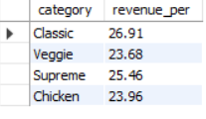

hich pizza sold the most in totals revenue and qty?
SELECT
pt.name,
round(SUM(p.price * od.quantity),0) AS TotalRevenue,
sum(od.quantity) as totalqty
FROM
pizzas p
JOIN
order_details od ON p.pizza_id = od.pizza_id
JOIN
pizza_types pt ON p.pizza_type_id = pt.pizza_type_id
GROUP BY pt.name
ORDER BY TotalRevenue DESC
LIMIT 1;

Analyze the cumulative revenue generated over time.
select order_date,
sum(revenue) over(order by (order_date)) as running_total
from
(select o.order_date,sum(p.price*od.quantity) as revenue
from pizzas p
join order_details od ON p.pizza_id = od.pizza_id
join orders o on od.order_id=o.order_id
group by o.order_date) as total_sales

